Women-Led Green Value Chain Development and Marine Conservation
Ebodjé – Coastal Landscape of Parc Marin Manyange na Elombo Campo, Cameroon

TF-RD is implementing an integrated conservation and green economy initiative in Ebodjé, a coastal community adjacent to a high-biodiversity marine protected area and critical sea turtle nesting beaches.

The project addresses the dual challenges of biodiversity loss and rural poverty by structuring the coconut value chain (Cocos nucifera) as a sustainable livelihood alternative for women, while reinforcing marine conservation efforts.

Before intervention, coconut exploitation was informal, low-value, and unstructured. TF-RD formalized 35 women into a legally recognized Common Initiative Group (GIC) named “Etengue a wù” (“Our Coconut”), strengthening governance, financial management, and market access.

Key achievements to date:
• 35 women trained in primary coconut processing and entrepreneurship
• 7 collective sales organized
• 14,287 coconuts commercialized
• 3,329,940 FCFA (≈4,934 USD) generated in direct revenue
• Memorandum of Understanding signed with a private sector buyer
• Construction of a solar-powered drying facility
• Establishment of a community-managed processing platform

To ensure long-term sustainability and climate resilience, TF-RD established a community nursery of 2,720 seedlings, including 1,375 coconut trees and indigenous species such as Irvingia gabonensis.

A total of 1,000 coconut trees were replanted along the coastline to combat marine erosion, enhance carbon sequestration, and strengthen community awareness on sea turtle protection.

Complementary capacity-building activities included soap production training, enabling women to diversify income sources and increase household resilience.

This initiative demonstrates a scalable model where women-led green enterprises:
• Reduce pressure on marine biodiversity
• Strengthen climate adaptation at the coastal level
• Enhance local value addition and market integration
• Promote gender-inclusive economic growth

TF-RD’s approach aligns with continental priorities on climate resilience, biodiversity conservation, women’s economic empowerment, and sustainable coastal development.

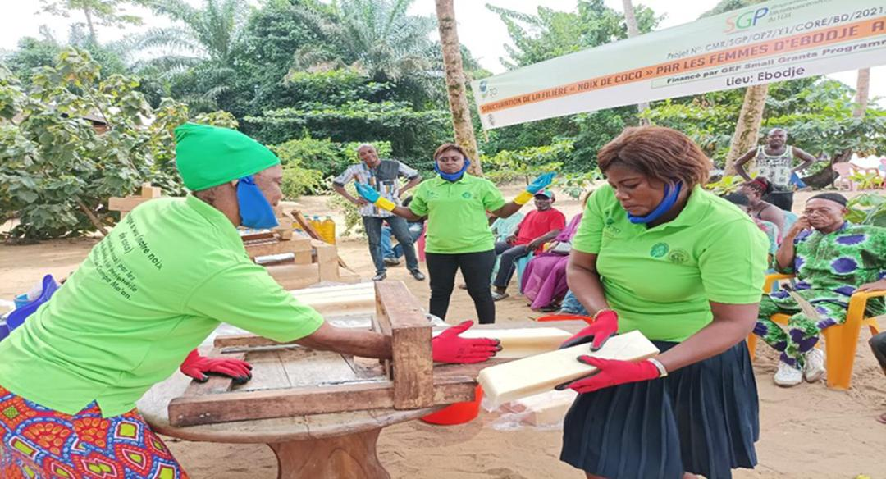

Complementary capacity-building activities included soap production training, enabling women to diversify income sources and increase household resilience.
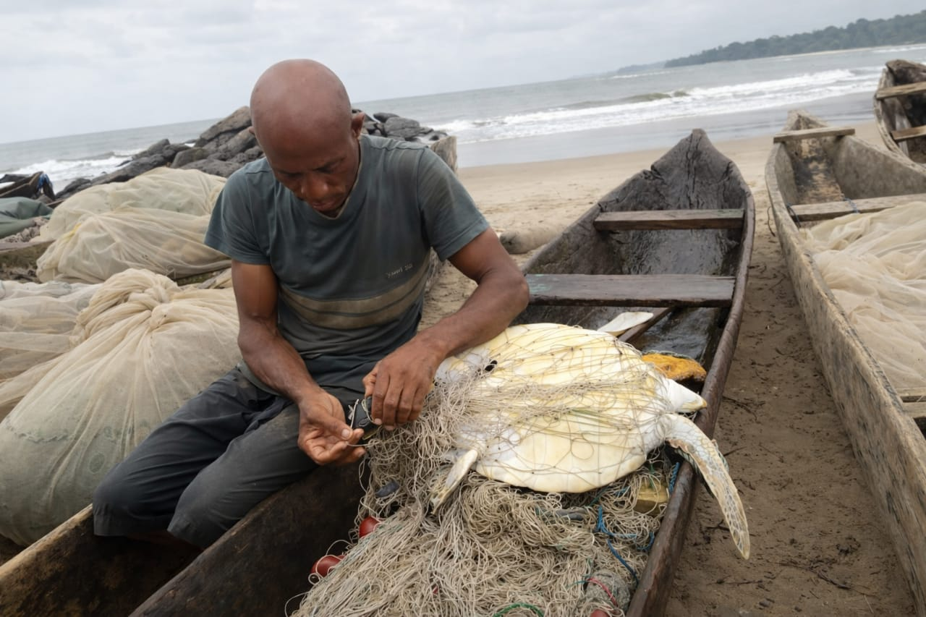
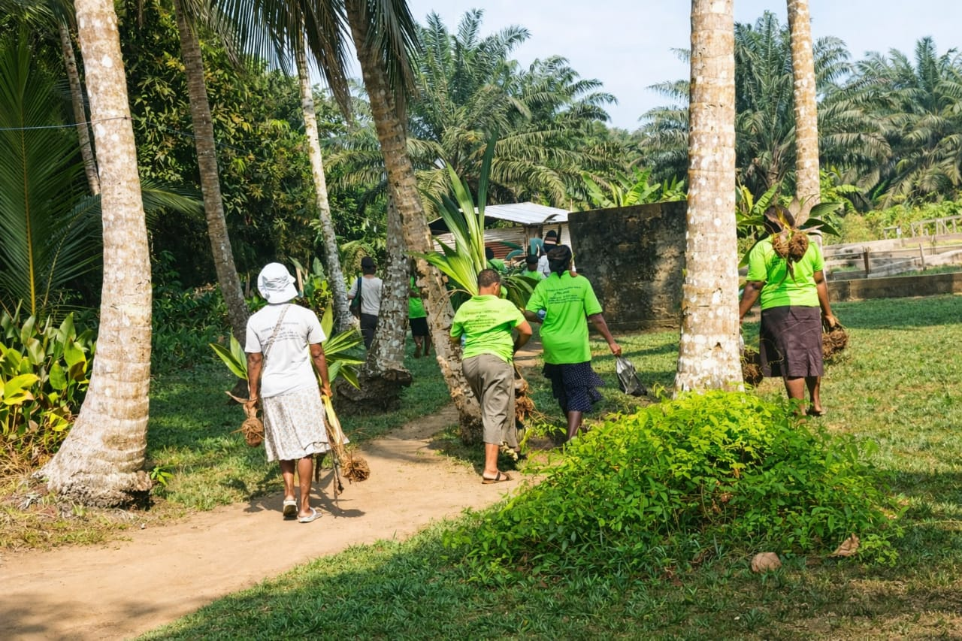
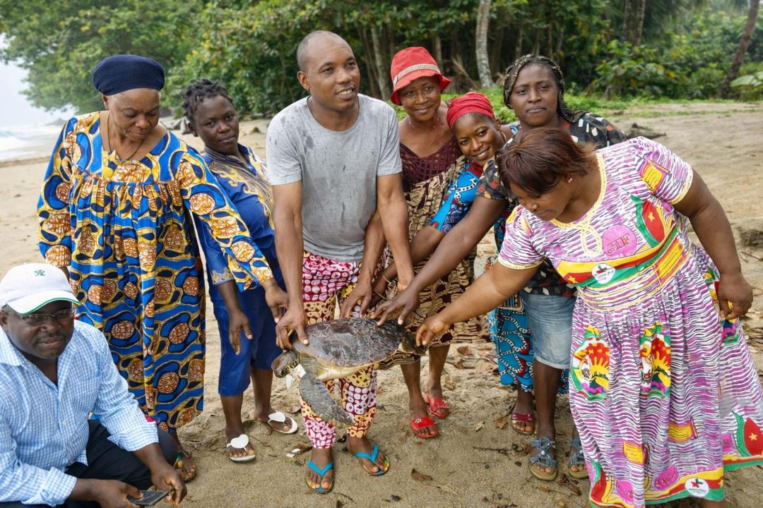

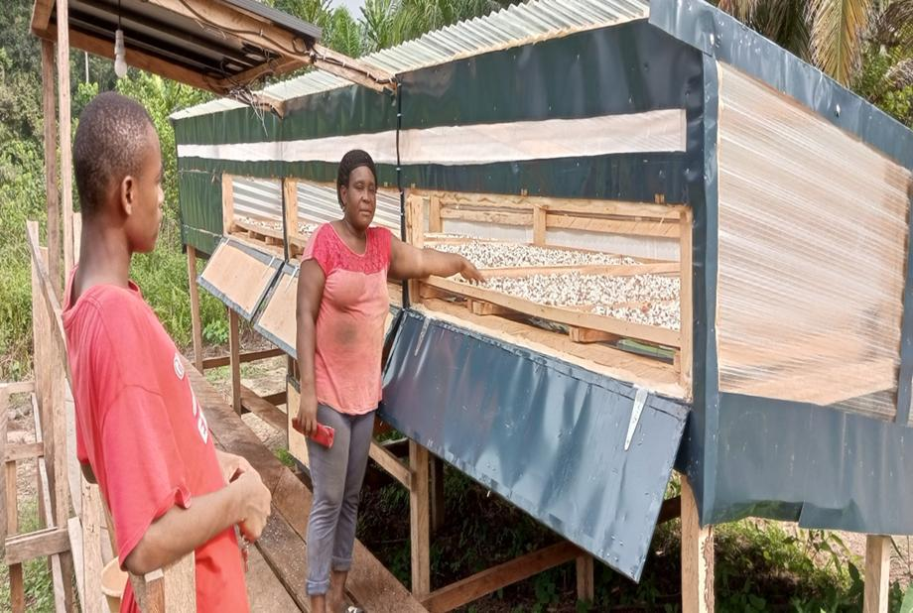

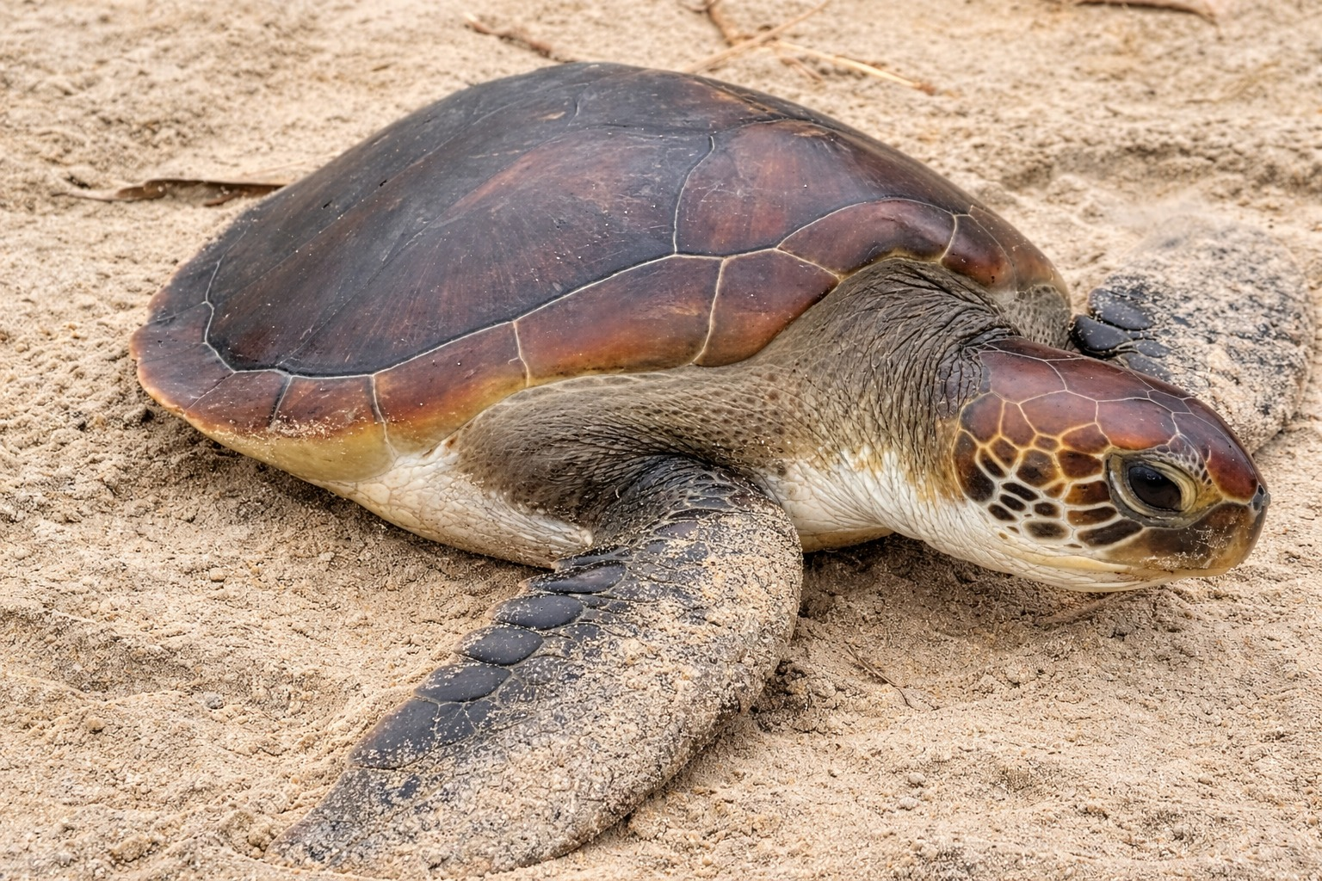

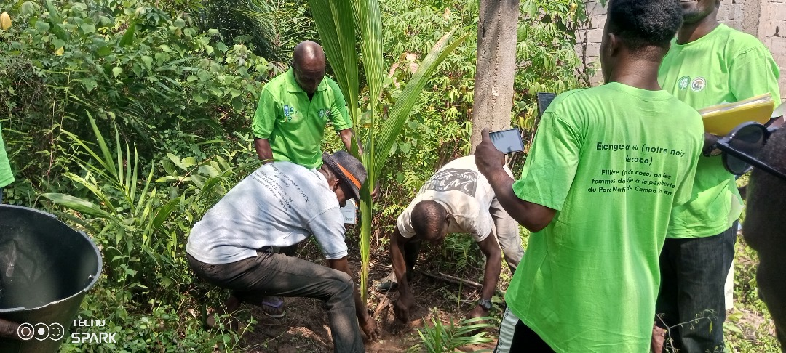

A total of 1,000 coconut trees were replanted along the coastline to combat marine erosion, enhance carbon sequestration, and strengthen community awareness on sea turtle protection.

